WAYNE OKOTH ODHIAMBO - 676143

IST1025 – Introduction to Programming

Coursework

Student Academic Monitoring and Support System (SAMSS)

SECTION A – SYSTEM DESIGN (ANALYZE & DESIGN)

1. Problem Analysis
The Student Academic Monitoring and Support System is designed to assist universities in Kenya in monitoring students’ academic performance and identifying those at risk of failure at an early stage.
Many universities face challenges such as difficulty in tracking student performance, delayed academic interventions, and lack of centralized systems for monitoring progress. This system provides a simple command-line solution to address these issues.

Core Functionalities
The system performs the following functions:
- Registers student details (name, ID, number of units, scores).
- Computes the average score.
- Determines the grade classification.
- Determines the academic risk level (Low, Moderate, High).
- Stores student records in a file.
- Retrieves and displays stored records.
- Provides a menu-driven interface.

Required Inputs
- Student Name (String)
- Student ID (String)
- Number of Units (Integer)
- Scores (Float values between 0–100)

Expected Outputs
- Student details
- Average score
- Grade classification
- Academic risk level
- Confirmation messages
- Display of saved student records

Potential Edge Cases
The system accounts for:
- Invalid inputs (letters instead of numbers)
- Scores outside the range 0–100
- Zero or negative number of units
- Empty records when viewing data
- Missing or corrupted data file
These are handled using input validation and error handling mechanisms.

2. System Architecture Design
The system uses a top-down modular design, breaking the problem into smaller manageable functions.

Functional Modules
Function | Purpose
main() | Controls program flow
register_student() | Collects student data
calculate_metrics() | Computes average, grade, risk
get_valid_input() | Validates user input
display_records() | Displays stored records
save_to_file() | Saves records to file
load_from_file() | Loads records from file

The system separates logic from input/output by ensuring that computation (such as calculating averages and determining grades) is handled in dedicated functions like calculate_metrics(), while user interaction is handled in functions such as register_student() and display_records(). This improves reusability and testing.

Data Structures Used

List
A list is used to store multiple student records:
students = []

Dictionary
Each student is stored as a dictionary:
student = {
"id": "1023",
"name": "John Mwangi",
"scores": [70, 80, 65],
"average": 71.7,
"grade": "A",
"risk_level": "Low"
}

Justification for Data Structures

Lists
- Allow storage of multiple student records
- Dynamic (can grow as more students are added)
- Easy iteration

Dictionaries
- Use key-value pairs for better organization
- Easy to access specific data (e.g., student["name"])
- Improves readability and maintainability

Maintainability
- Each function performs a single task
- Code is easy to debug and update
- Changes in one module do not affect others

Avoiding Redundancy
- Reusable functions (e.g., validation function)
- Loops used instead of repeated code
- Centralized logic for calculations

Scalability
The system can be expanded to include:
- Fee tracking
- Attendance monitoring
- Academic warnings
- Integration with databases

3. System Design Diagram

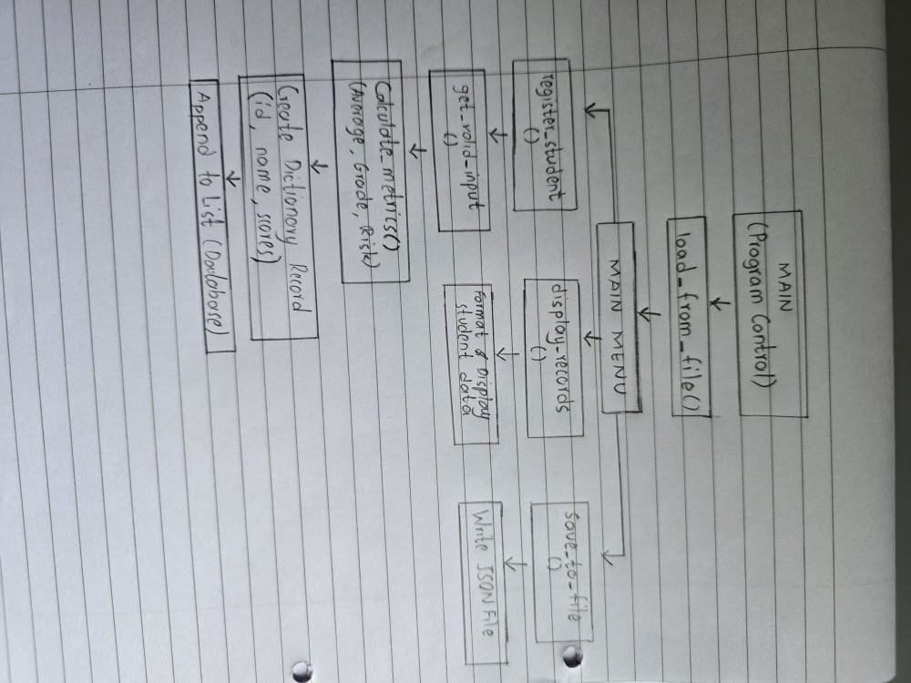

SECTION B – IMPLEMENTATION (PYTHON PROGRAM)
import json
import os
# -------------------------------
# LOGIC MODULE
# -------------------------------
def calculate_metrics(scores):
"""Computes average, assigns grade and risk level"""
if not scores:
return 0.0, "F", "High"
avg = sum(scores) / len(scores)
if avg >= 70:
grade = "A"
elif avg >= 60:
grade = "B"
elif avg >= 50:
grade = "C"
elif avg >= 40:
grade = "D"
else:
grade = "F"
if avg >= 60:
risk = "Low"
elif avg >= 40:
risk = "Moderate"
else:
risk = "High"
return round(avg, 2), grade, risk
# -------------------------------
# VALIDATION MODULE
# -------------------------------
def get_valid_input(prompt, input_type=float, min_val=None, max_val=None):
while True:
try:
value = input_type(input(prompt))
if min_val is not None and value < min_val:
print(f"Minimum value is {min_val}")
continue
if max_val is not None and value > max_val:
print(f"Maximum value is {max_val}")
continue
return value
except ValueError:
print("Invalid input. Try again.")
# -------------------------------
# REGISTER STUDENT
# -------------------------------
def register_student(students_list):

print("\n--- Register Student ---")

s_id = input("Enter Student ID: ")

# Fix: Proper indentation
while True:
name = input("Enter Student Name: ").strip()
if name:
break
print("Name cannot be empty.")

units = get_valid_input("Enter number of units: ", int, 1)

scores = []
for i in range(units):
score = get_valid_input(f"Enter score for unit {i+1}: ", float, 0, 100)
scores.append(score)

avg, grade, risk = calculate_metrics(scores)

student = {
"id": s_id,
"name": name,
"scores": scores,
"average": avg,
"grade": grade,
"risk_level": risk
}

students_list.append(student)

print(f"Student {name} registered successfully!")
# -------------------------------
# DISPLAY RECORDS
# -------------------------------
def display_records(students_list):
if not students_list:
print("No records found.")
return
print("\n" + "="*60)
print(f"{'ID':<10}{'Name':<20}{'Avg':<10}{'Grade':<10}{'Risk'}")
print("="*60)
for s in students_list:
print(f"{s['id']:<10}{s['name']:<20}{s['average']:<10}{s['grade']:<10}{s['risk_level']}")
# -------------------------------
# SAVE FILE
# -------------------------------
def save_to_file(students_list):
try:
with open("samss_data.json", "w") as file:
json.dump(students_list, file, indent=4)
print("Records saved successfully.")
except Exception as e:
print("Error saving file:", e)
# -------------------------------
# LOAD FILE
# -------------------------------
def load_from_file():
if os.path.exists("samss_data.json"):
try:
with open("samss_data.json", "r") as file:
return json.load(file)
except:
return []
return []
# -------------------------------
# MAIN MENU
# -------------------------------
def main():
students = load_from_file()
while True:
print("\n=== SAMSS MENU ===")
print("1. Register Student")
print("2. View Records")
print("3. Save & Exit")
choice = input("Enter choice: ")
if choice == "1":
register_student(students)
elif choice == "2":
display_records(students)
elif choice == "3":
save_to_file(students)
print("Exiting system...")
break
else:
print("Invalid choice. Try again.")
# -------------------------------
# PROGRAM ENTRY# -------------------------------
if __name__ == "__main__":
main()

